5.2 Functionality/Algorithm development

ReadyCare was designed with 3 user role-based permissions: The user who can create booking by selecting a date and time and then selecting a professional carer for booking. The professional who can upload their documentations, accept and manage bookings, display their profile with information on themselves and set their times/dates available to work. The admin who can approve professionals and have an oversight of bookings. Having these three role-based views allow for set access so that users cannot access any views they should not be which is crucial to preventing data leaks. The full user journeys have been captured in the flow diagrams below. These represent the algorithm development for each flow.

5.2.1 Care Professional User Journey
The following flow charts explain the registration, login and user functionalities for a care professional.

Registration
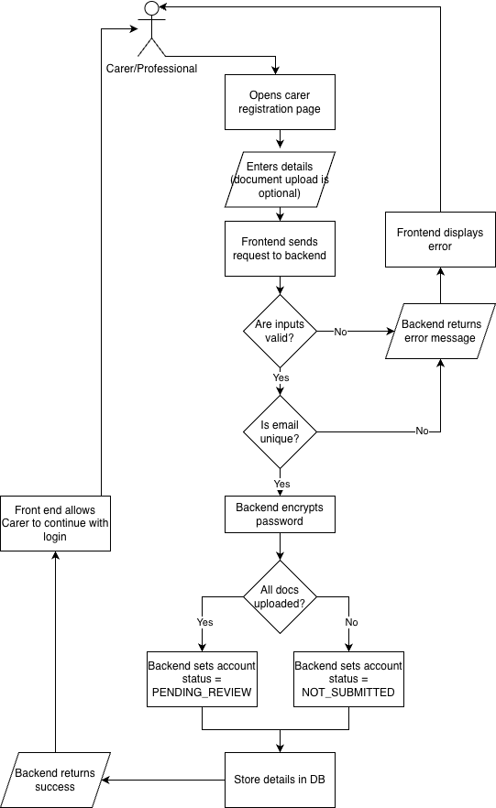

Login
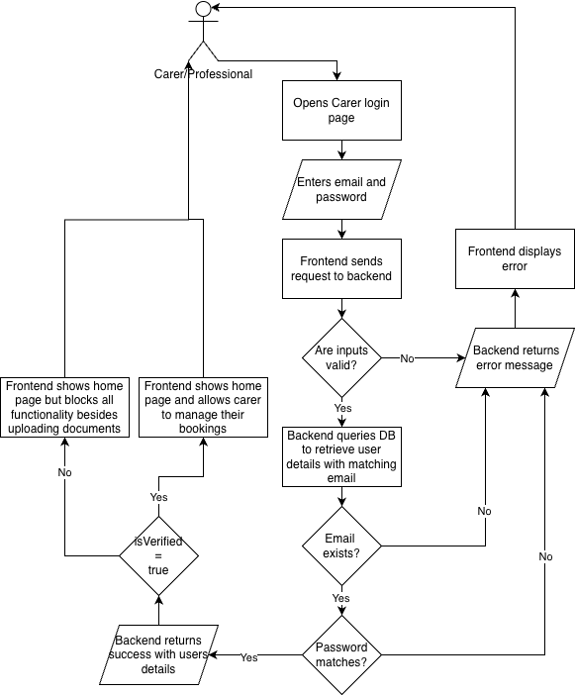

User Functionality
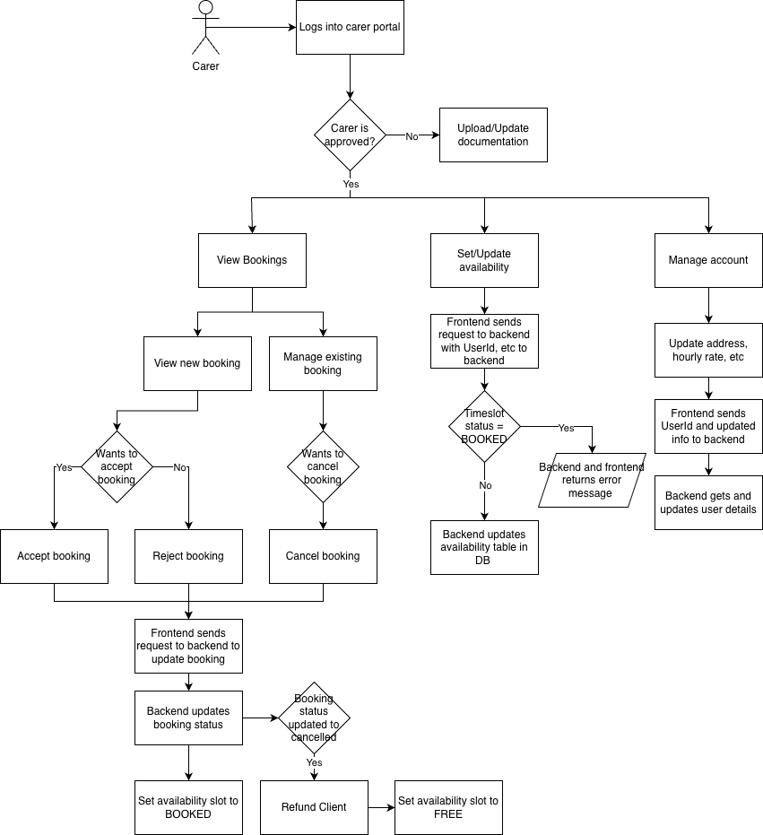

5.2.2 Client User Journey

Registration
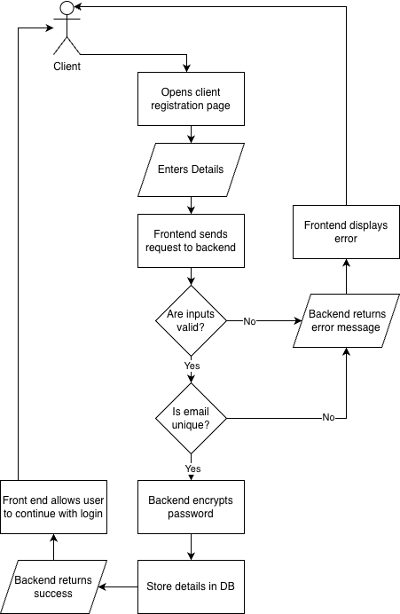

Login
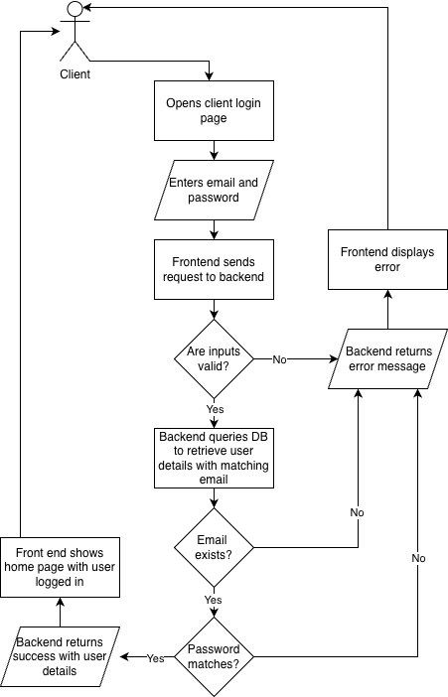

User Functionality
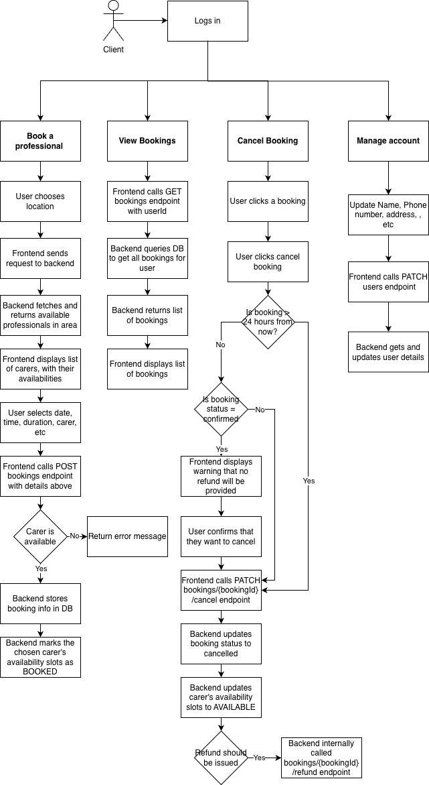

5.2.3 Admin User Journey

Registration
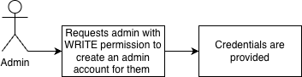

Login
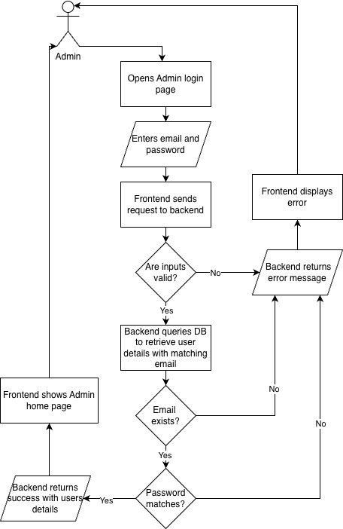

User Functionality
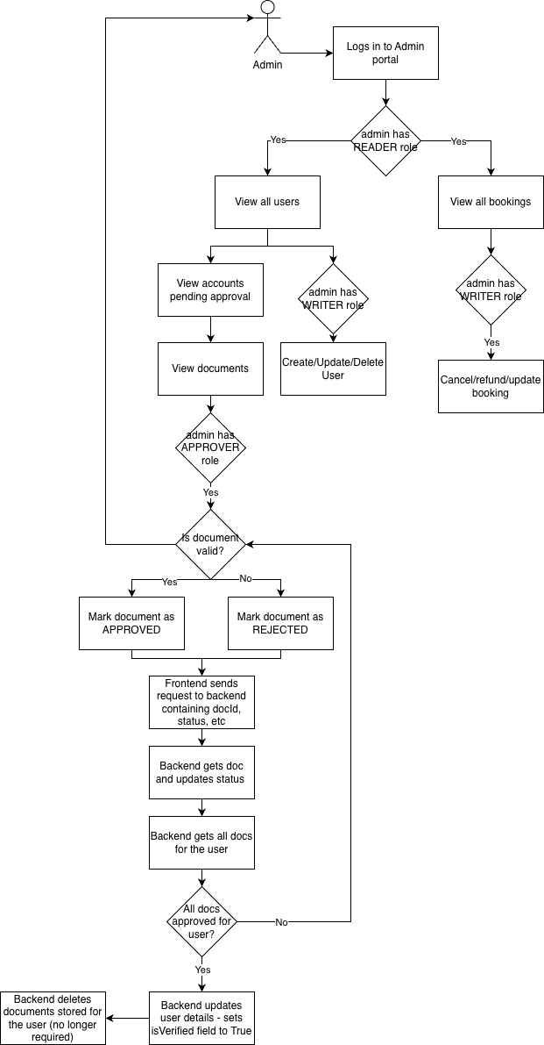

5.3 User Interfaces

5.3.1 Design Methodology

User-Centred Design (UCD)
A User Centred Design (UCD) method of approach was carried out when designing the interface of ReadyCare. Emphasis was placed on understanding the expectations and needs of the user as regardless of how sleek a website looks, ultimately the most important part is how it functions so that the user is not confused whilst navigating through the site causing frustration.
To do this I researched my target audience which is variable. The age of users could range anywhere from young, middle age or the elderly. This is since those that require care, come in all different ages. Although the younger audience have experience with technology within schools and mobile devices, the middle aged and elderly lack the experience and therefore require the need of useability. To ensure I had a simple system in place I created an easy workflow, so the user is not confused on where to navigate in their user journey. For example, when the user visits the site, they are shown a book now button on which they are taken to a view of the dates they would like to select, then time and then they are shown available carers for that day, to then selecting and continuing to payment. This easy workflow allows for all ages to be able to navigate through the app prioritising accessibility and workflow aligning with the user needs. (Clapp, 2025)

Usability Heuristics
When creating the interface of my website I followed usability heuristics proposed in an article by Jacob Nielsen (Nielsen, 1994). Visibility of system status and consistency and standards were a key standout as for example, clear confirmation of booking confirmations and approval status updates of care professionals signing up. Visuals like this allows for ease of use when navigating through the website.
Error prevention also influenced the design of my project for example, through input validation and booking checks. Things such as preventing users from double booking, requiring mandatory fields (name, phone number, address) and preventing professionals from offering their service until they are approved all allows for error prevention in schedule conflicts, invalid details and unauthorised access. Applying these principles allows for a better and professional user experience.

5.3.2 Mock-ups
Overview
- Colour scheme
For the colour scheme, a simple palette of colours was decided to be used in order to keep the Ui minimalistic and
- Font
- Text size
- Navigation bar location

5.3.2.1 Mock ups for Care Professional user interface
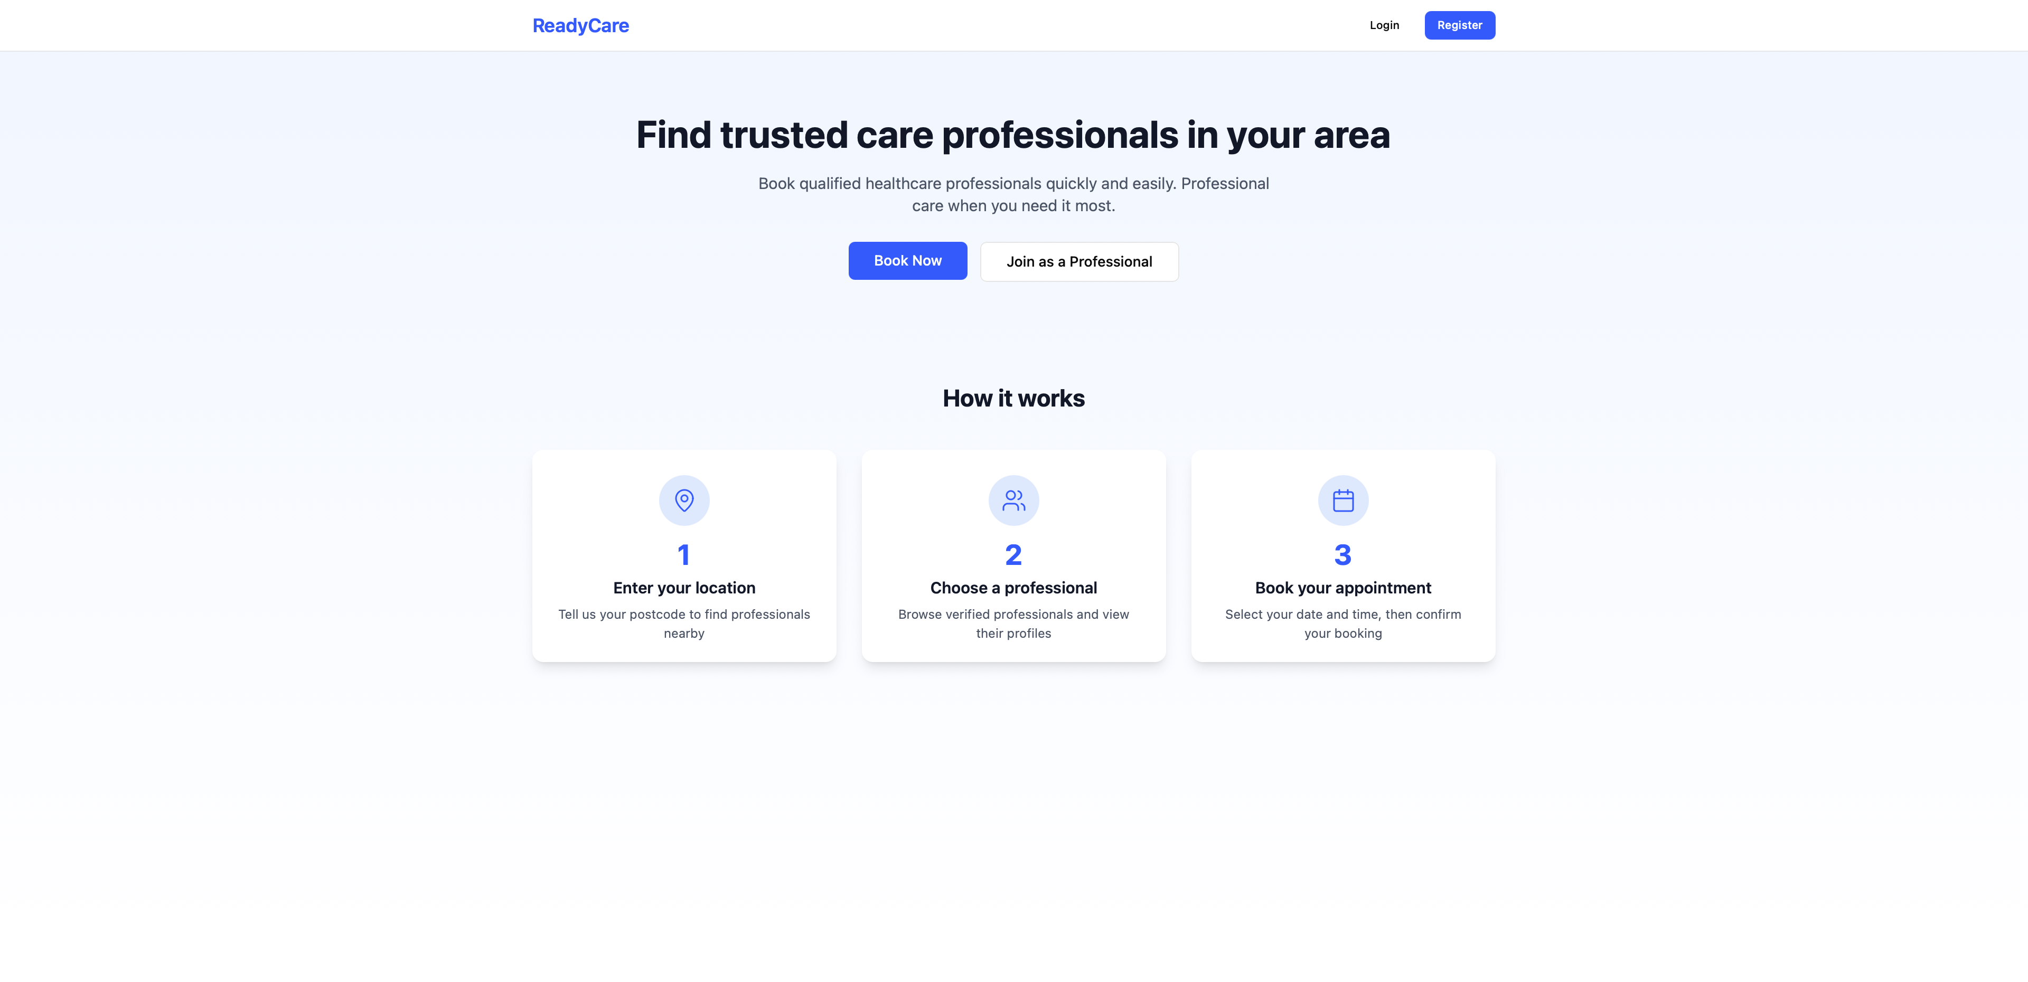
Home page > Click log in
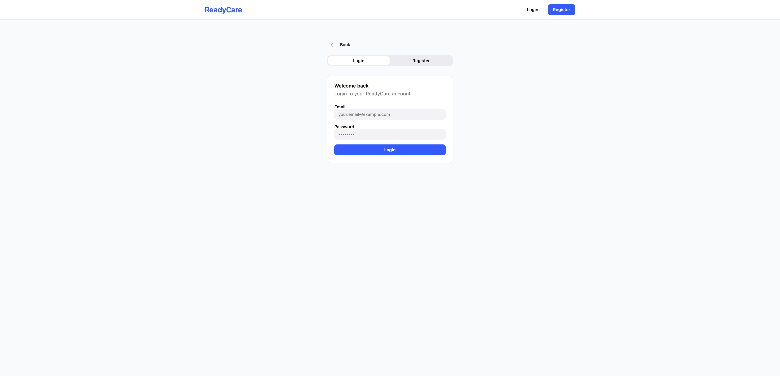
Log in view
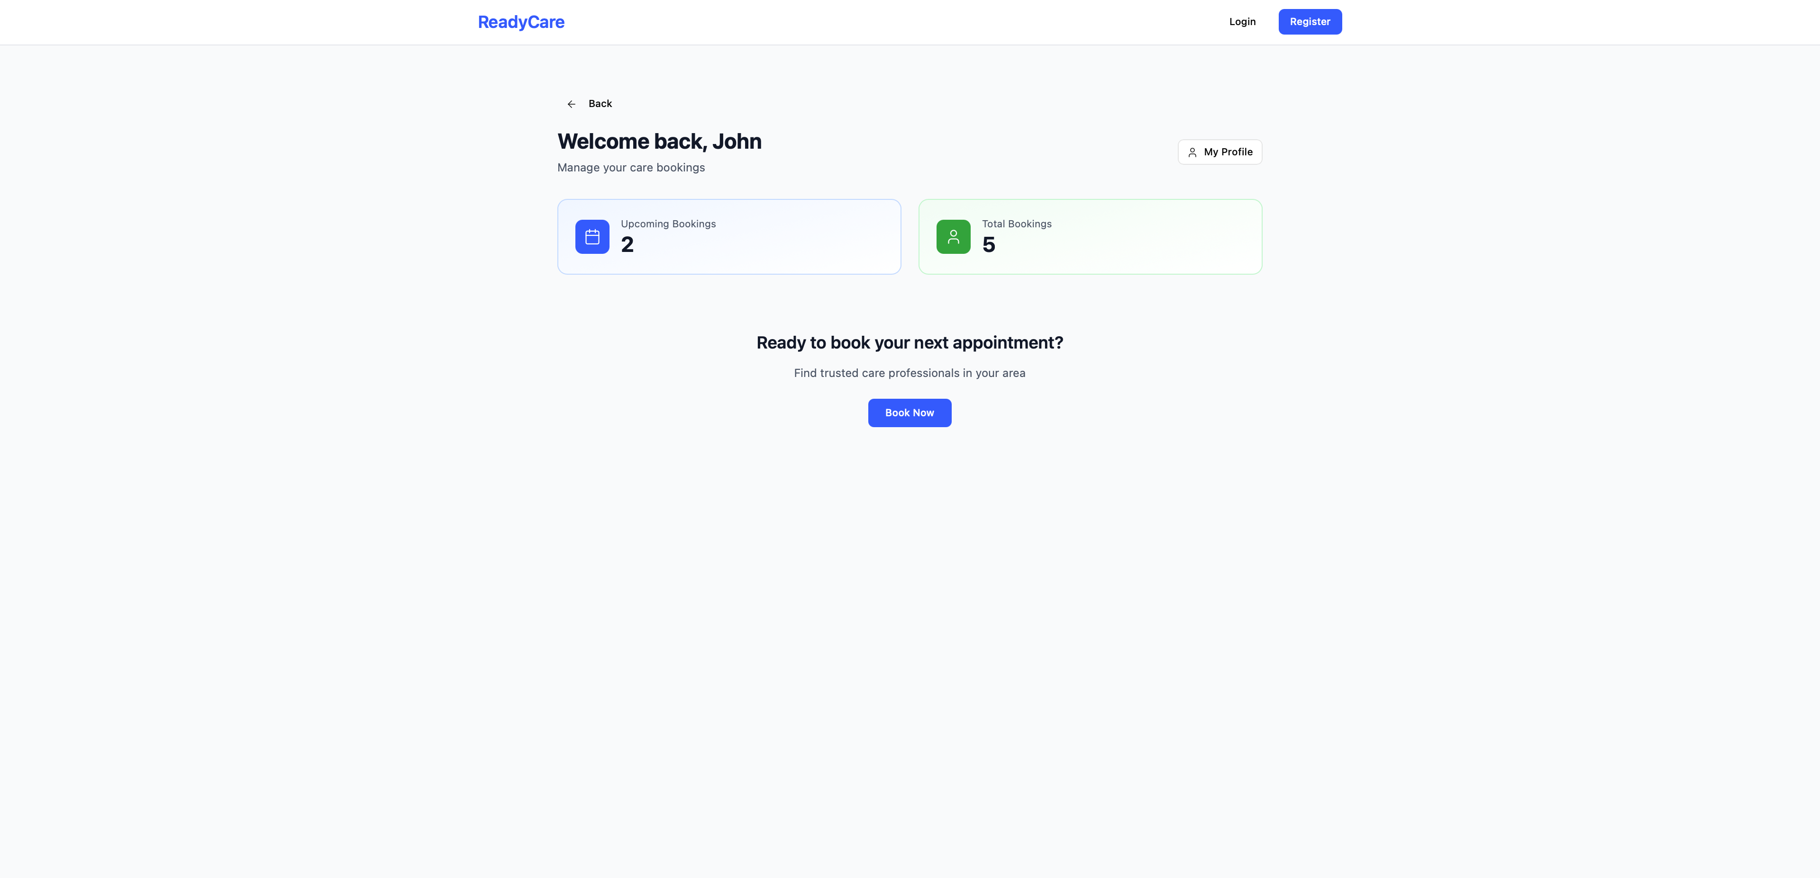
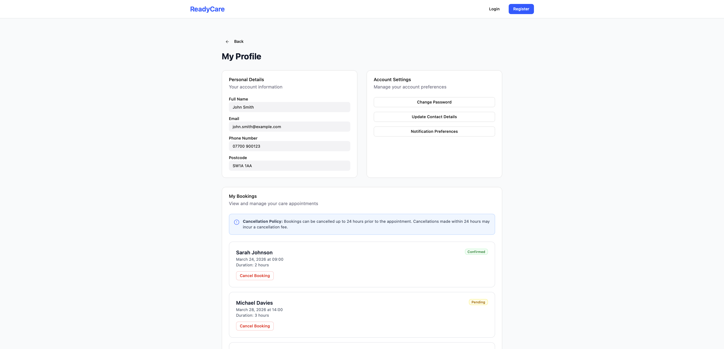

5.3.2.2 Mock ups for Client user interface
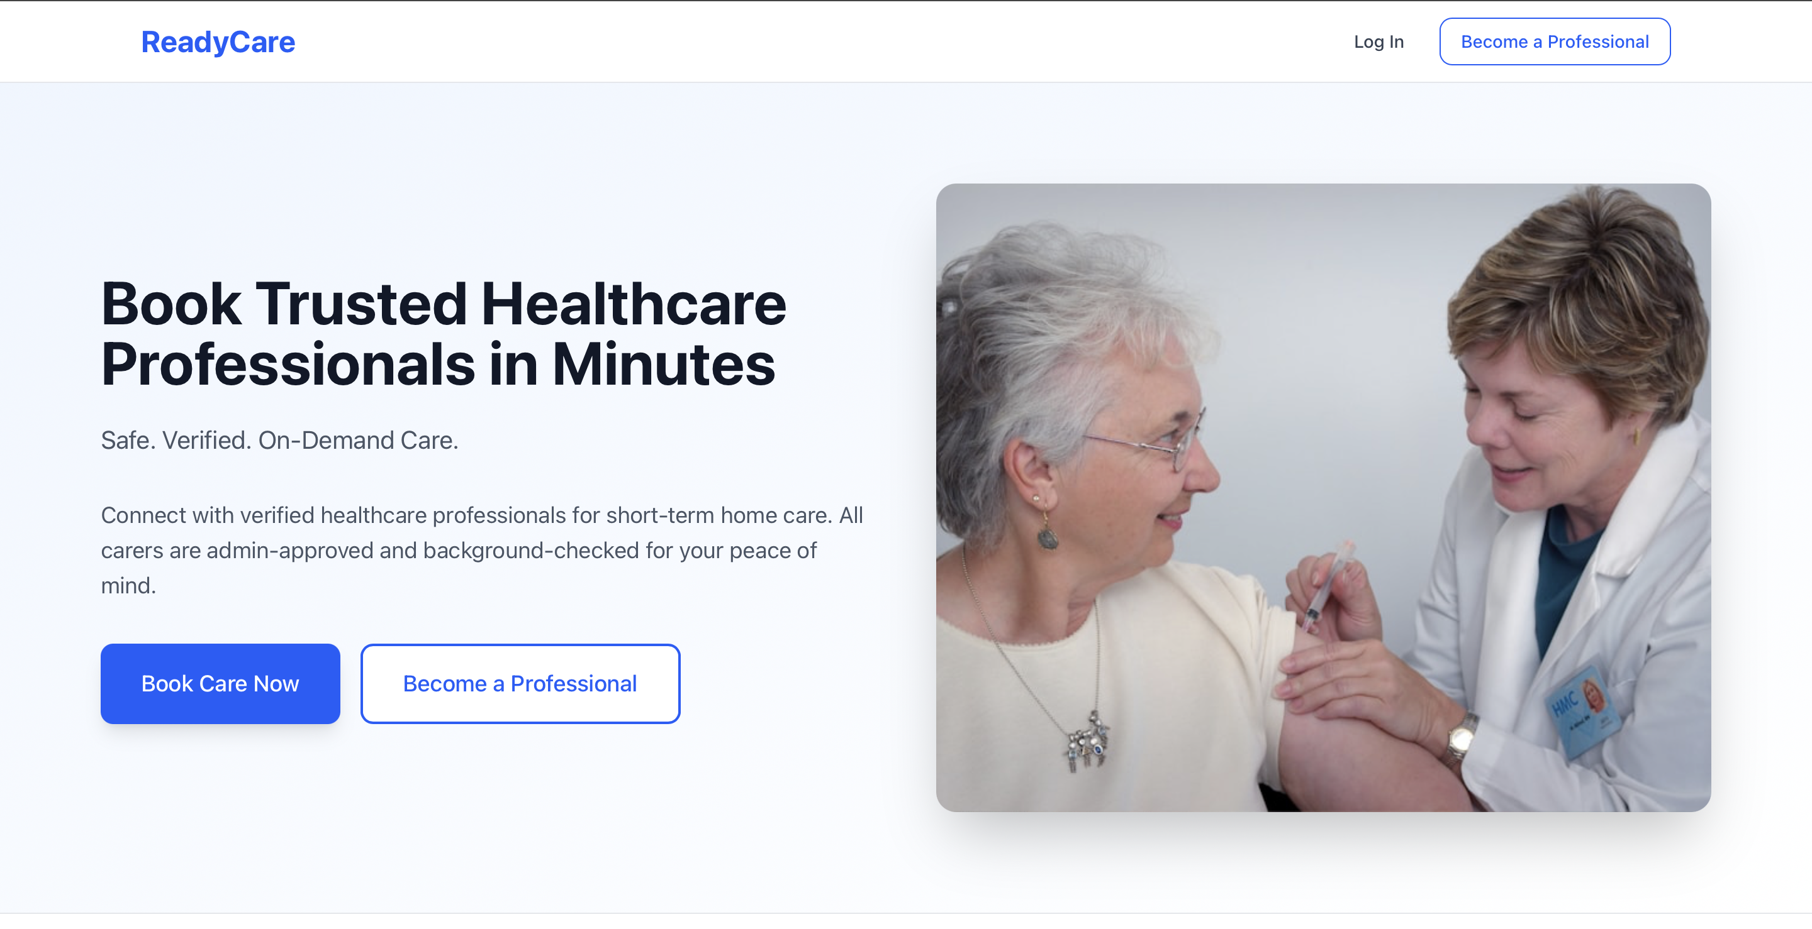
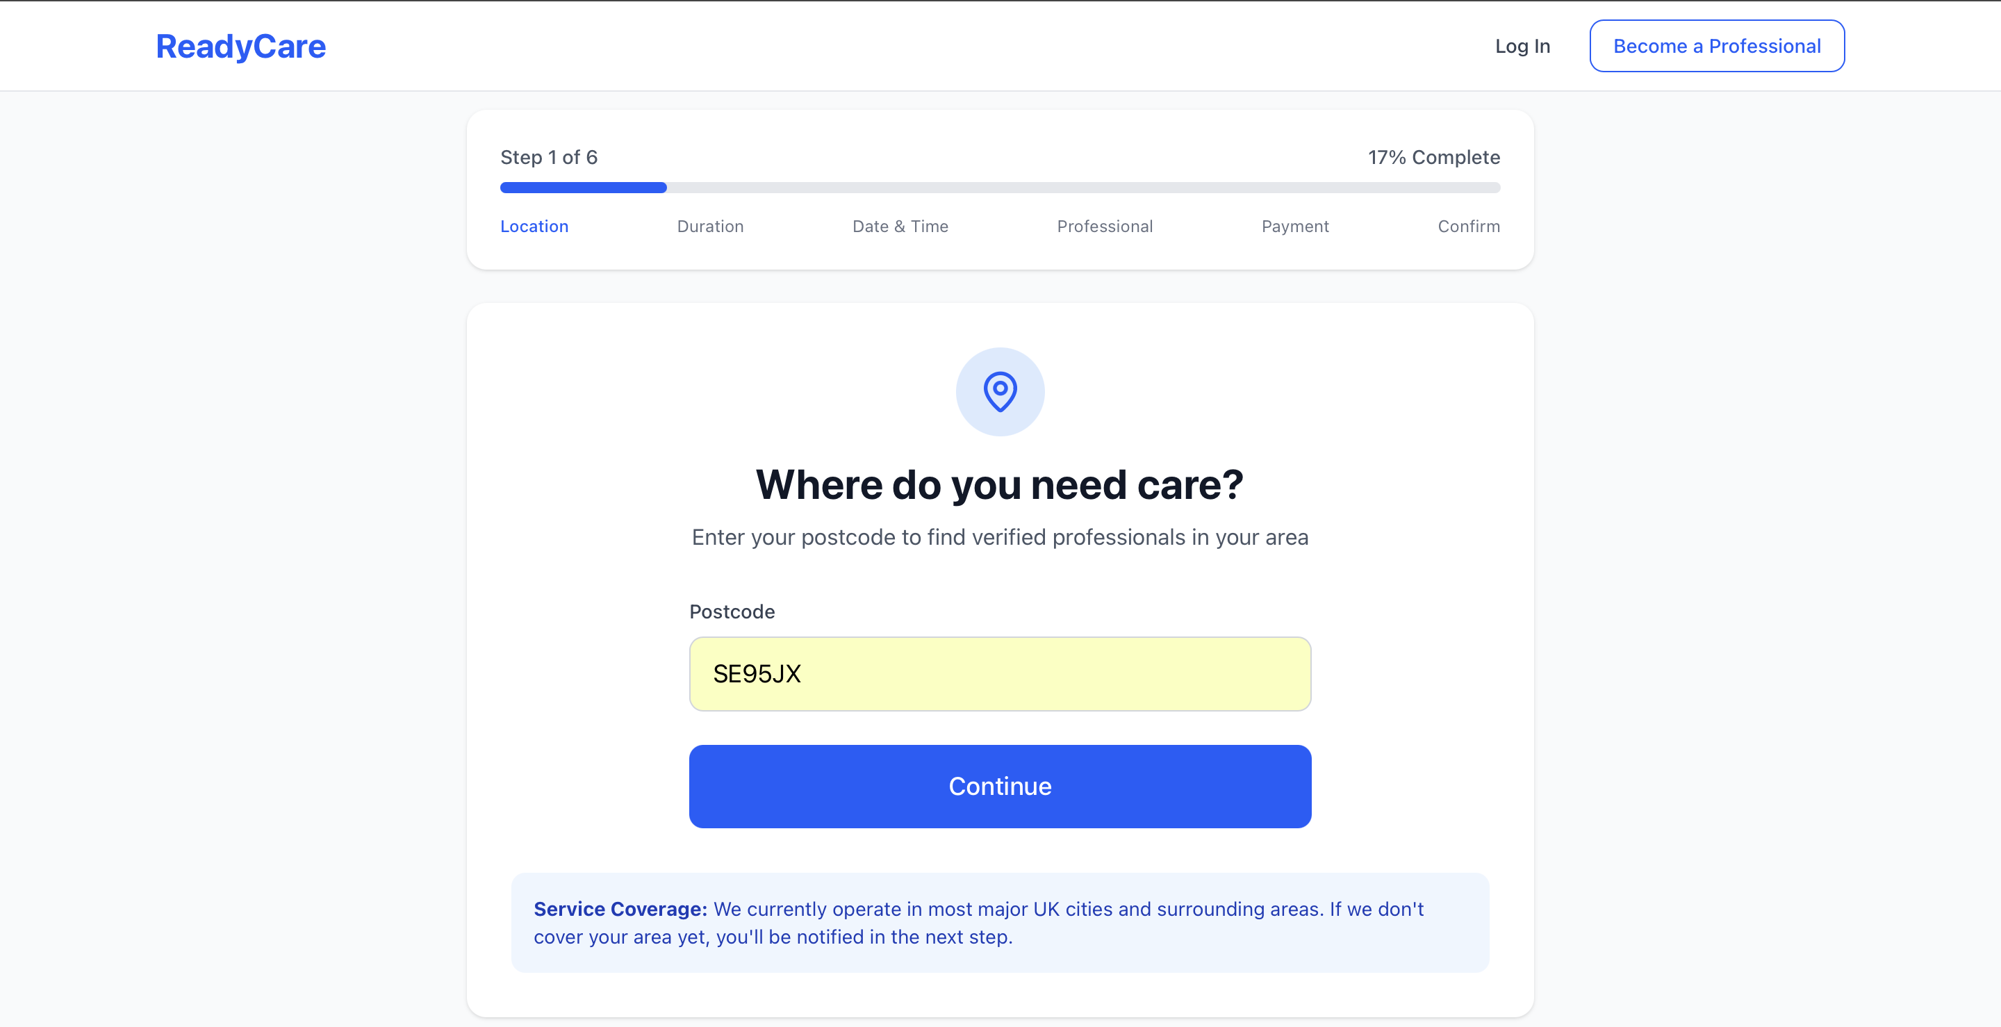

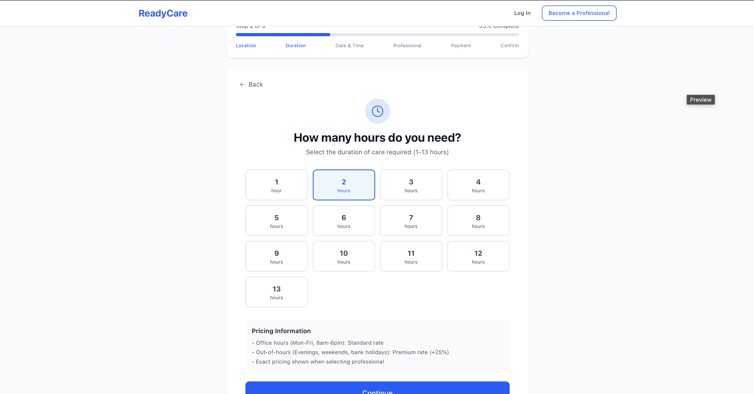

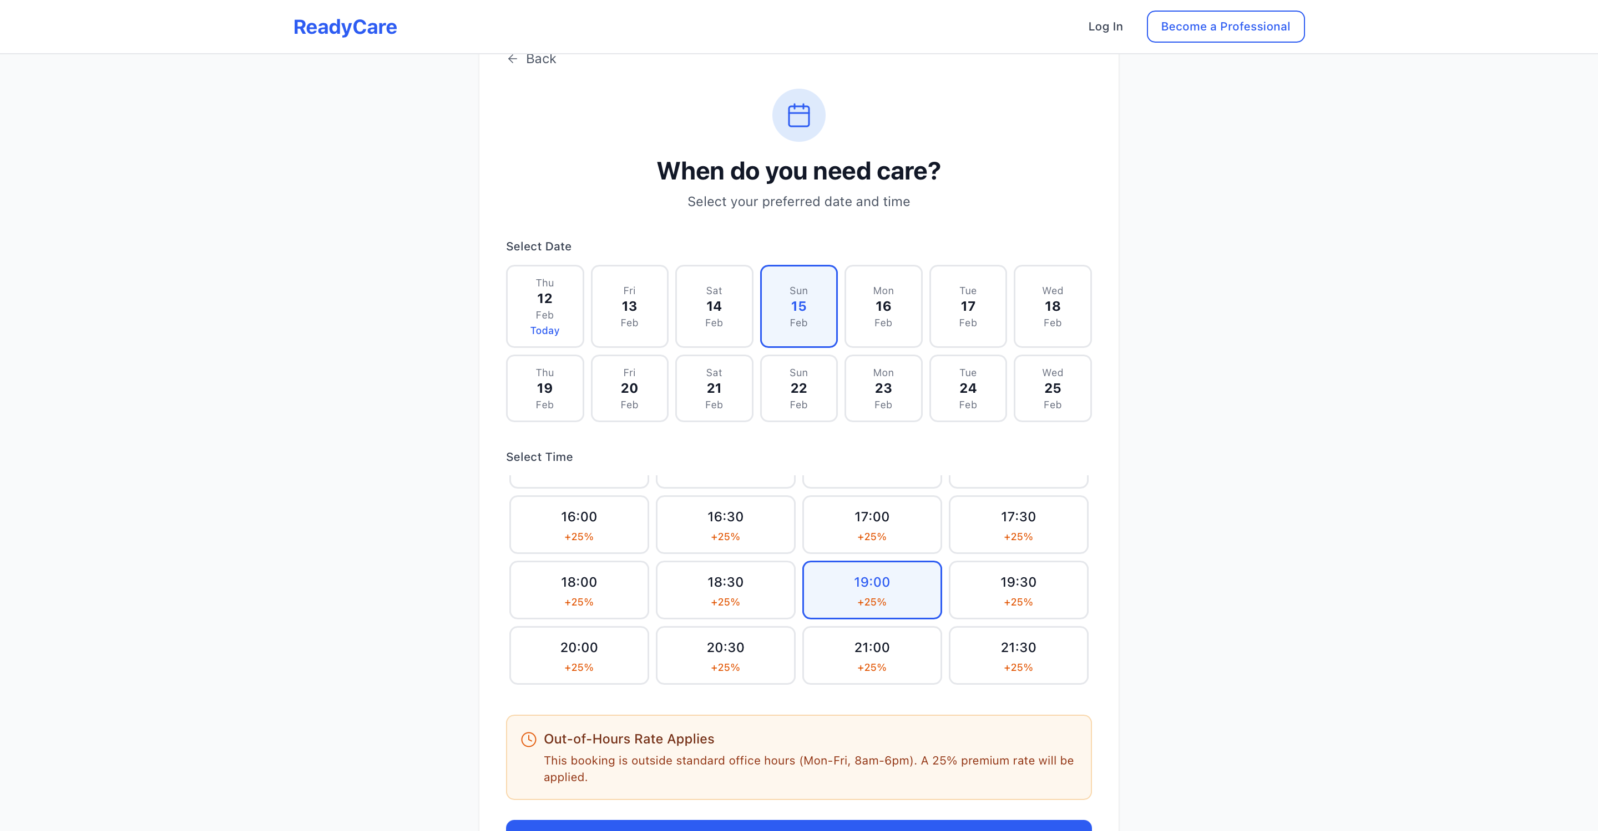

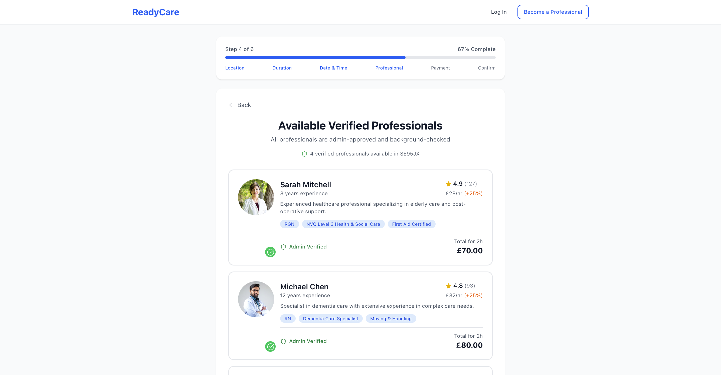
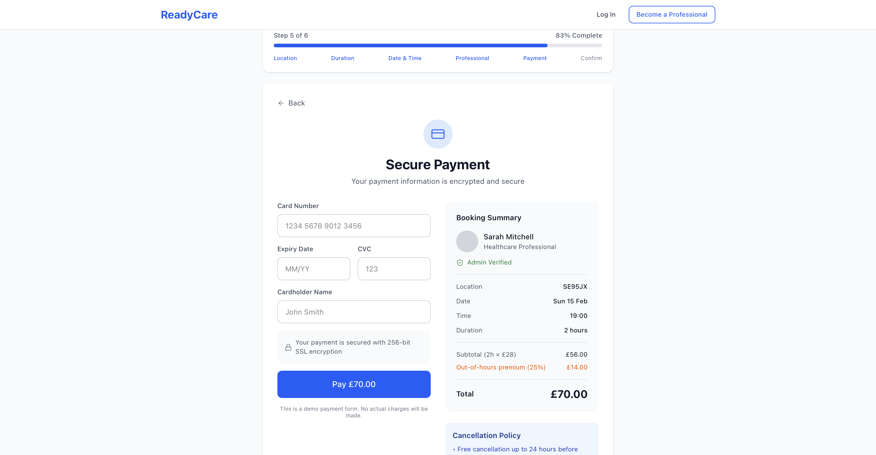

5.3.2.3 Mock ups for Admin user interface

